**Sumita Jain**

**Week 1 Homework: Excel – Video Games Sales**

1. **Nintendo – each dot reflects all games in a single genre**

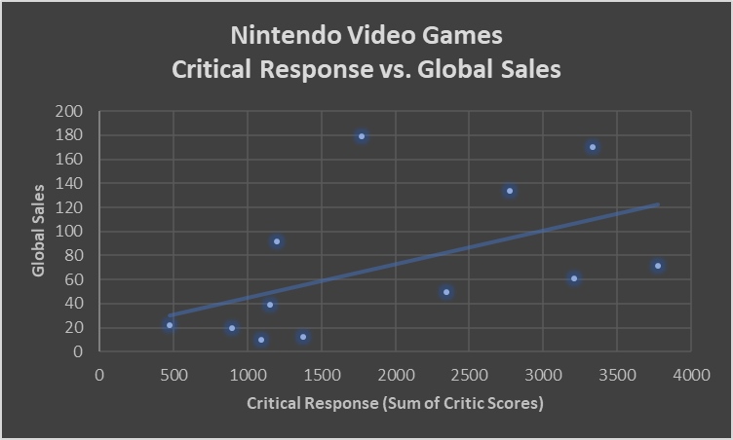

1. **Electronic Arts – each dot reflects all games in a single genre**